1. **OBJECTIVES**

See the requirements document

1. **HARDWARE DESIGN**

See the PCB Artist schematic file

1. **SOFTWARE DESIGN**

No change in software design (call graphs and data flow graphs are the same as those provided in the lab manual).

1. **MEASUREMENT DATA**
   1. **Show the data and calculated resolution, range, precision and accuracy**

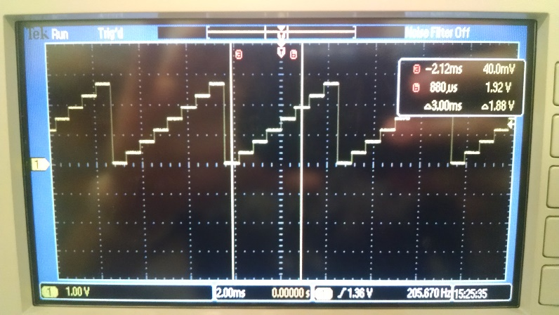

*Figure 1: Experimental measurement of the DAC output for 8 different digital inputs.*

*Our DAC’s actual output range is ~3 Volts (which makes sense because our*

*Vref was 1.5 Volts. Our DAC seemed to output less voltage than expected for*

*most of the tested values.*

|  |  |  |  |  |  |  |  |  |  |  |  |  |  |  |  |  |  |  |  |  |  |  |  |  |  |  |  |  |  |  |  |  |  |  |  |  |  |  |  |  |  |  |  |  |  |  |  |  |
| --- | --- | --- | --- | --- | --- | --- | --- | --- | --- | --- | --- | --- | --- | --- | --- | --- | --- | --- | --- | --- | --- | --- | --- | --- | --- | --- | --- | --- | --- | --- | --- | --- | --- | --- | --- | --- | --- | --- | --- | --- | --- | --- | --- | --- | --- | --- | --- | --- |
| |  |  |  |  |  |  |  |  |  |  | | --- | --- | --- | --- | --- | --- | --- | --- | --- | --- | | Digital Input | 0 | 512 | 1024 | 1536 | 2048 | 2560 | 3072 | 3584 | 4096 | | DAC Measured Output (V) | 0.07 | 0.43 | 0.81 | 1.19 | 1.57 | 1.93 | 2.3 | 2.68 | 3.05 | | Expected Output (V) | 0 | 0.4125 | 0.825 | 1.2375 | 1.65 | 2.0625 | 2.475 | 2.8875 | 3.3 | | Delta = Actual - Expected | 0.07 | 0.0175 | -0.015 | -0.0475 | -0.08 | -0.1325 | -0.175 | -0.2075 | -0.2467 | |  |  |  |  |  |  |  |  |
|  |  |  |  |  |  |  |  |  |
|  |  |  |  |  |  |  |  |  |
|  |  |  |  |  |  |  |  |  |

**Range:** 0 to 3.3V

**Precision:** 4096

**Resolution: (**range / precision) = 0.81mV

**Accuracy:**

**4.2 Show the experimental response of DAC including SNR**

**4.3 Show the results of the debugging profile**

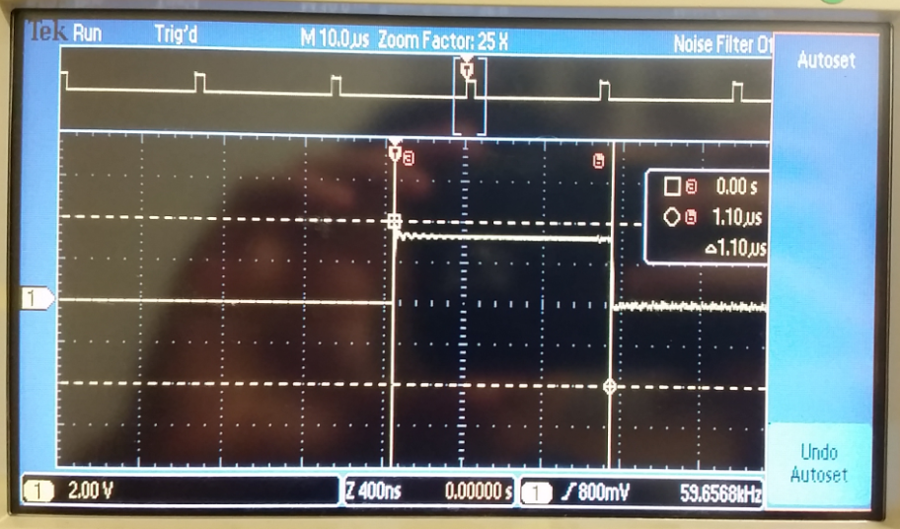

*Figure 1: This ISR shows the time it takes to output to the DAC (~1 microsecond)*

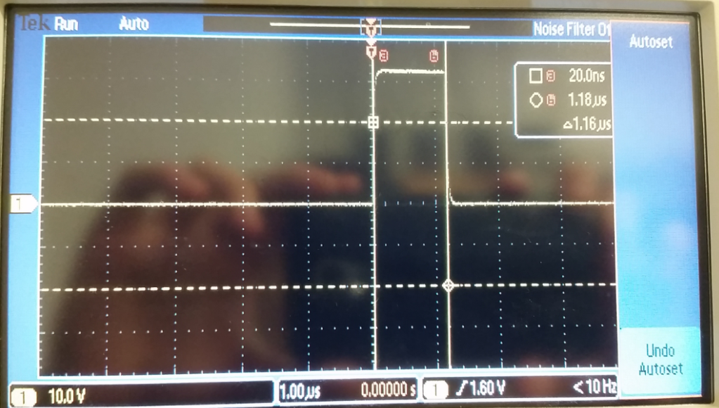

*Figure 2: This ISR shows the time it takes to change the tempo.*

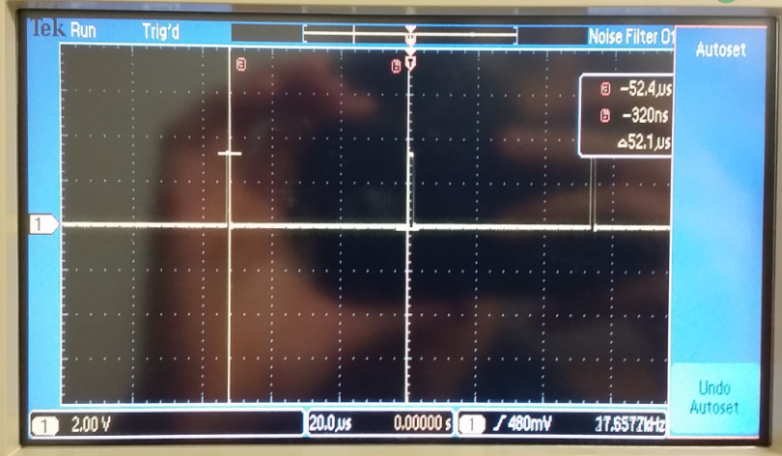

*Figure ###: The time between*

**4.4 Measurements of current required to run the system, with and without the music playing**

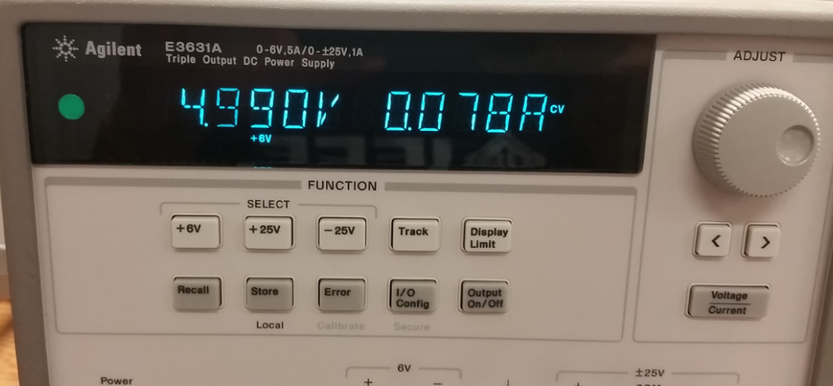

*Figure 3: about 78 mA was required to run the system without music playing*

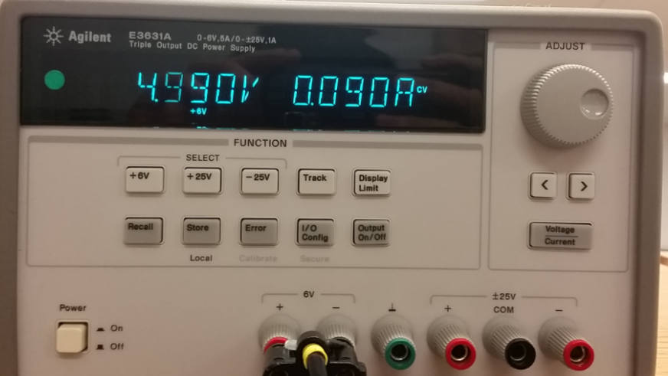

*Figure 4: about 90 mA was required to run the system with music playing*

*(this value did shoot up to 120-130 mA when playing louder music)*

1. **ANALYSIS AND DISCUSSION**
   1. **Briefly describe three errors in a DAC**

i) Offset Error: The difference between the DAC output and 0V when 0 is applied at the input.

ii) Full-scale Error: The difference between ideal and actual DAC output when max input is applied. Very dependent on Vref stability.

iii) Gain Error: Full-scale Error minus Offset Error. Deviation of input to output slope from ideal value.

* 1. **Calculate the data available and data required intervals in the SSI/DAC interface. Use these calculations to justify your choice of SSI frequency**
  2. **How is the frequency range of a spectrum analyzer determined?**
  3. **Why did we not simply drive the speaker directly from the DAC? What is the purpose of using the TPA731?**